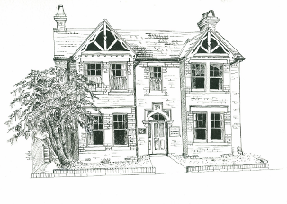
New Patient Registration Form
Goldington Avenue Surgery
Please complete all pages in full using block capitals

1. Background Details
Contact Details
First Name |  |  | Middle name
Surname |  |  | Previous Surname  (if applicable)
Address |  |  | Date of Birth
 |  |  | Home Telephone
 |  |  | Mobile Telephone
I consent to be contacted* by SMS on this number: Yes ¹ No
Next of Kin² | Name: | Tel: |  |  | Relationship:
Power of Attorney³ | Yes No
We will also require sight of the original ‘health and welfare’ POA document, as a copy of this will be retained on your records – the original must be seen.
Office use only:
Original document copy taken by:
Original document seen on:
Reminder added to home page:
Have you been registered with the NHS before? Yes No
If no please state date entered UK:

* It is your responsibility to keep us updated with any changes to your telephone number, email & postal address.
We may contact you with appointment details, test results, health campaigns or Patient Participation Group details
If you do not consent to being contacted by SMS or Email, please tick here: SMS Email

2. Patient consent to discuss confidential medical information
I would like to give access to the following person/s to have access to all of my confidential medical information, to allow them to hold conversations on my behalf with practice staff.
Person 1 |  | Name: | Tel: |  | Relationship:
Person 2 |  | Name: | Tel: |  | Relationship:
Signature I wish to give access to the above named person/people, and agree with the following statement:

Sharing my information with anyone else is at my own risk
If I think I may come under pressure to give access to someone else, I will contact the practice as soon as possible

Signature
Name
Date

Other Details ⁴
Ethnicity | White (UK)  White (Irish)  White (Other) | Black Caribbean  Black African  Black Other | Bangladeshi  Indian  Pakistani | Chinese  Other
Religion | C of E  Catholic  Other Christian | Buddhist  Hindu  Muslim | Sikh  Jewish  Jehovah’s Witness | No religion  Other:
Armed Forces | Military Veteran | Family member

Communication Needs
Language⁵ | What is your main spoken language?  Do you need an interpreter? Yes No
Communication | Do you have any communication needs? Yes No (If Yes please specify below)
 | Hearing aid  Lip reading | Large print  Braille | British Sign Language  Makaton Sign Language Guide dog
Learning disability ⁶ | Do you have a Learning Disability? Yes No Unsure  (If Unsure please request a Learning Disability Screening Tool form)

Carer Details⁷
Are you a carer? | Yes – Informal / Unpaid Carer |  | Yes – Occupational / Paid Carer |  | No
Do you have a carer? | Yes | Name*: | Tel: | Relationship:
* Only add carer’s details if they give their consent to have these details stored on your medical record

3. Medical History⁸
Medical History
Have you suffered from any of the following conditions?
Asthma  COPD  Epilepsy | Heart Disease  Heart Failure  High Blood Pressure | Diabetes  Kidney Disease  Stroke | Depression  Underactive Thyroid  Cancer- Type:
Any other conditions, operations or hospital admission details:

If you are currently under the care of a Hospital or Consultant outside our area, please tell us here:

Family History
Please record any significant family history of close relatives with medical problems and confirm which relative e.g. mother, father, brother, sister, grandparent

Asthma………………….  COPD………………...…  Epilepsy………………… | Heart Disease……….…  Stroke…………….……..  Blood Pressure………… | Diabetes………..………  Kidney Disease..………  Liver Disease..….…….. | Depression………..……  Thyroid…………..….…..  Cancer…………………..
Other:

Allergies⁹
Please record any allergies or sensitivities below

Current Medication
Please check and include as much information about your current medication below
Please give us your previous repeat medication list if possible, as a medication review appointment may be needed

Medical History
Please give brief details of any serious or current medical problems/illnesses; any operation or accidents; and a brief history of past pregnancies if applicable.
Please include dates where possible:

4. Your Lifestyle
Alcohol¹⁰
Please answer the following questions which are validated as screening tools for alcohol use:

AUDIT–C QUESTIONS | Scoring System |  |  |  |  | Your Score
 | 0 | 1 | 2 | 3 | 4
How often do you have a drink containing alcohol? | Never | Monthly or Less | 2-4 times per month | 2-3 times per week | 4+ times per week
How many units of alcohol do you drink on a typical day when you are drinking? | 1-2 | 3-4 | 5-6 | 7-9 | 10+
How often have you had 6 or more units if female, or 8 or more if male, on a single occasion in the last year? | Never | Less than monthly | Monthly | Weekly | Daily or almost daily
A score of less than 5 indicates lower risk drinking |  |  |  |  | TOTAL:
Scores of 5 or more requires the following 7 questions to be completed:
AUDIT QUESTIONS  (after completing 3 AUDIT-C questions above) | Scoring System |  |  |  |  | Your Score
 | 0 | 1 | 2 | 3 | 4
How often during the last year have you found that you were not able to stop drinking once you had started? | Never | Less than monthly | Monthly | Weekly | Daily or almost daily
How often during the last year have you failed to do what was normally expected from you because of your drinking? | Never | Less than monthly | Monthly | Weekly | Daily or almost daily
How often during the last year have you needed an alcoholic drink in the morning to get yourself going after a heavy drinking session? | Never | Less than monthly | Monthly | Weekly | Daily or almost daily
How often during the last year have you had a feeling of guilt or remorse after drinking? | Never | Less than monthly | Monthly | Weekly | Daily or almost daily
How often during the last year have you been unable to remember what happened the night before because you had been drinking? | Never | Less than monthly | Monthly | Weekly | Daily or almost daily
Have you or somebody else been injured as a result of your drinking? | No |  | Yes, but not in last year |  | Yes, during last year
Has a relative or friend, doctor or other health worker been concerned about your drinking or suggested that you cut down? | No |  | Yes, but not in last year |  | Yes, during last year
 |  |  |  |  | TOTAL:
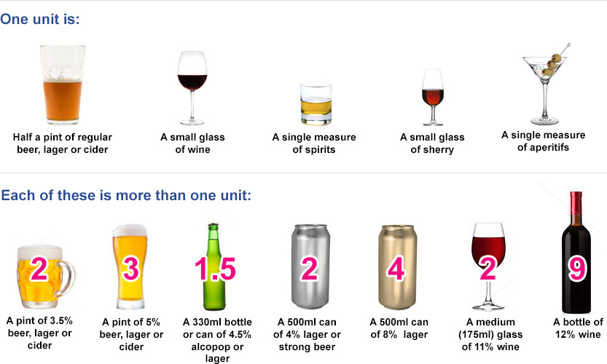

5. Your Lifestyle - Continued
Smoking¹¹
Do you smoke? | Never smoked | Ex-smoker | Yes
Do you use an e-Cigarette? | No | Ex-User | Yes
How many cigarettes did/do you smoke a day? | Less than one | 1-9 10-19 | 20-39 40+
Would you like help to quit smoking? | Yes | No
 | For further information, please see: https://www.bedford.gov.uk/social-care-health-and-community/public-health/smoking/

Height & Weight¹²
Height
Weight
BMI
If your BMI 30 or over, we can refer you to NHS weight management service | Yes please refer me to NHS weight management service

Women Only
Do you use any contraception?  Do you have a coil or implant insitu | Yes No If needed, please book appointment.  Yes No Date inserted:
Are you currently pregnant or think you may be? | Yes No Expected due date:

6. Further Details
Electronic Prescribing
If you would like your prescriptions to be sent electronically,  please provide details of the pharmacy you would like to use: | Pharmacy:
7. Sharing Your Health Record¹³
SUMMARY CARE RECORD

Summary Care Records (SCR) are an electronic record of important patient information, created from GP medical records. They can be seen and used by authorised staff in other areas of the health and care system involved in the patient’s direct care. Access to SCR information means that care in other settings is safer, reducing the risk of prescribing errors - it also helps avoid delays to urgent care (e.g. A&E). At a minimum, the SCR holds important information about current medication, allergies and sensitivities and name, address, date of birth and NHS number of the patient. By default a basic SCR will be created at the point of registration. You can also choose to opt for an enhanced SCR where details of long term conditions, significant medical history or specific communication needs will be visible to other care settings (including A&E).
Would you like to have an enhanced SCR? (Your GP would recommend you have this, but it remains your choice)

Yes
No , please complete form

There is an option to opt out of having a SCR altogether – this means authorised staff in other areas of the health and care system will not have access to important information about your health. If you want to opt out, ask Reception for the opt-out form or complete online https://digital.nhs.uk/services/summary-care-records-scr/scr-patient-consent-preference-form

8. Application for online access ¹³
Would you like full access to your medical records:

Yes
No

If yes, we need to see your ID: Passport or Driving licence or European national identity card.
If one of these cannot be provided, then we will require two forms of the following where one is photographic and one for address:
Bus pass, University ID card, NHS ID card, Library card, Utility bill, Council tax bill, Bank statement.

I wish to access my medical record & understand & agree with each statement: Please tick all that apply
I have read and understood the ‘Important Information’ section below
I will be responsible for the security of the information that I see or download
If I choose to share my information with anyone else, this is at my own risk
I will contact the practice as soon as possible if I suspect that my account has been accessed by someone without my agreement
If I see information in my record that it not about me, or is inaccurate I will log out immediately and contact the practice as soon as possible

For Practice Use Only:

Identity verified through  (tick all that apply) | Self Vouching  Vouching with information in record  Photo ID (………………………………………………………………..)  Bank statement  Utility bill
Name of Verifier |  | Date
Name of person who authorised and added to SystmOne |  | Date

This consent can be verbally withdrawn by the patient at any point by speaking to a member of staff
Checklist
Please ensure the following are done and provided so that your registration can be completed successfully
Completed & Signed Above Form
Completed & Signed GMS1 Form
Photo Proof of ID e.g. Passport, Photo Driving License or Photo ID card
Proof of Address e.g. Bank statement, Utility Bill or Council Tax from within the last 3 months

